**Practical 4**

**SQL queries to retrieving data from multiple Tables**

***Query1. Write SQL query to list out Product ID, Product name, Unit cost and Sales date from Product_2120, Sales_2120.***

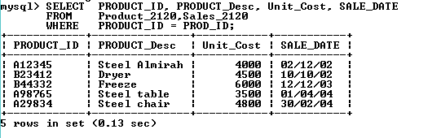

***Query2. Write SQL query to retrieve Product name, Sales date of product which have Product ID A12345.***

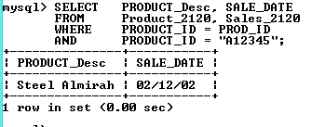

***Query3. Write SQL query to list out name of customer and address of customer who brought the product id A23412.***

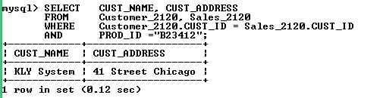

***Query4. Write SQL query to List out the name of customer and their country name, which brought product date “01-01-02” to “31-12-04”.***

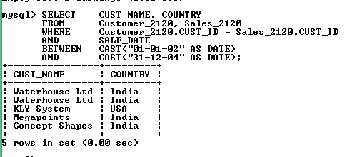

***Query5. Write SQL query to list out the customer name, Address, Country, Quantity, of product and selling of date product.***

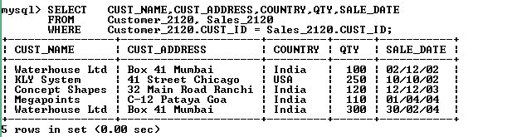

***Query6. Write SQL query to Product name, Sales date of product which have unit cost 4000 and 6700.***

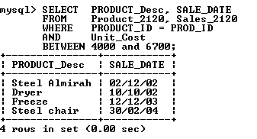

***Query7. Write SQL query to list out name of employee and there Ssn number who working location Houston at Sugarland.***

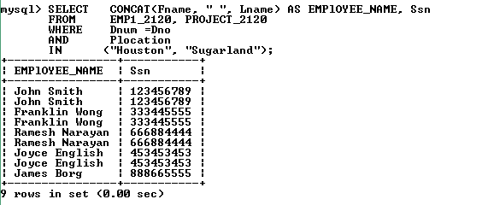

***Query8. Write SQL query to list out Name of Dependent of employee of John smith.***

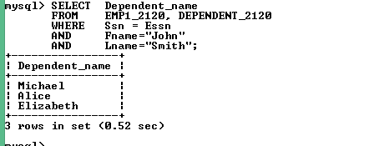

***Query9. Write SQL query to list out Name of employee and DOB, address, who working in reorganization.***

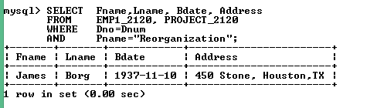

***Query.10. Write SQL query to list out the department name, employee name, Ssn, Mgr. Start date of employee those who working in Administration.***

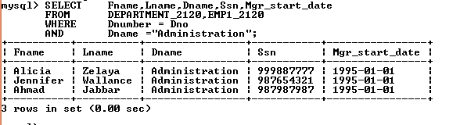 ***Query11. Write SQL to list out Customer name, Telephone no, Sale date, and quantity of products.***

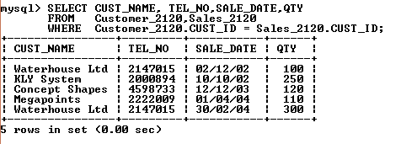

***Query12. Write SQL query to list out product name, sale date, and quantity.***

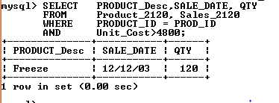

***Query13. Write SQL query to list out Fname, Lname, DOB, Sex and department location.***

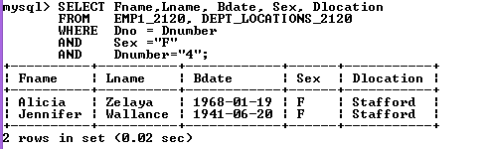

***Query14. Write SQL query to list out Fname, department name which have number in 1, 4.***

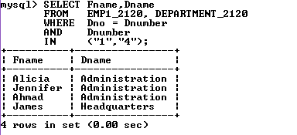

***Query15. Write SQL query to list out Fname, Lname as Employee Name, Ssn, Address, Sex, Salary, Hours of working.***

